(A CHRISTIAN MINORITY INSTITUTION) JAISAKTHI EDUCATIONAL TRUST

BANGALORE TRUNK ROAD, VARADHARAJAPURAM, NASARATHPET, POONAMALLEE, CHENNAI 600 123

**DEPARTMENT OF**



# ARTIFICIAL INTELLIGENCE AND DATA SCIENCE

**AD8412 – DATA ANALYTICS LABORATORY ACADEMIC YEAR: 2021 – 2022 (EVEN SEMESTER)**

Name of the Student :

Register Number :

Roll Number :

Year & Semester :



# REGISTER NUMBER:

Certified that this is a bonafide record of practical work done by

of II Year / III

Semester of B.Tech Artificial Intelligence and Data Science in AD8412 – DATA ANALYTICS LABORATORY during the academic year 2021 - 22.

# STAFF IN-CHARGE HEAD OF THE DEPARTMENT

Submitted for the Anna University practical examination held on at Panimalar Institute of Technology, Chennai – 600 123.

# INTERNAL EXAMINER EXTERNAL EXAMINER

**INDEX**

|  |  |  |  |  |
| --- | --- | --- | --- | --- |
| **Expt. No.** | **Name of the Experiment** | **Page No** | **Date** | **Signature** |
| 1 | Demonstration the random sampling |  |  |  |
| 2 | Demonstrate the probability sampling from a known population |  |  |  |
| 3 | Implementation of Z-Test – One Sample Z-Test and Two Sample Z-Test |  |  |  |
| 4 | Implementation of Z-Test – using Titanic case study |  |  |  |
| 5 | Implementation of T-Test – one sample t-test |  |  |  |
| 6 | Implementation of T-Test – Two sample t-test and Paired T-Test |  |  |  |
| 7 | Implementation of VARIANCE ANALYSIS ( ANNOVA) |  |  |  |
| 8 | Demonstration of Linear Regression |  |  |  |
| 9 | Demonstration of Logistic Regression |  |  |  |
| 10 | Demonstration of Multiple-Linear Regression |  |  |  |
| 11 | Implementation of Time Series Analysis |  |  |  |

# PROGRAM

**1 A) Picking Random Items in a List using ‘random.choice()’**

bmi_list = [29, 18, 20, 22, 19, 25, 30, 28,22, 21, 18, 19, 20, 20, 22, 23]

import random

print("First random choice:", random.choice(bmi_list)) print("Second random choice:", random.choice(bmi_list)) print("Third random choice:", random.choice(bmi_list)) **OUTPUT:**

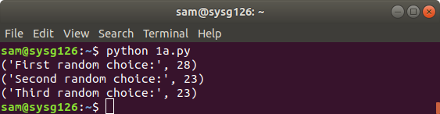

# 1 B) Picking Random Items in a List using ‘random.sample()’

print("Random sample, N = 5 :", random.sample(bmi_list, 5))

print("Random sample, N = 10:", random.sample(bmi_list, 10))

# OUTPUT:

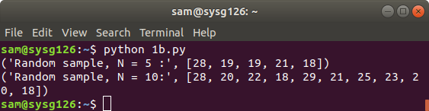

print("BMI list: ", bmi_list) random.shuffle(bmi_list) print("Shuffled BMI list: ", bmi_list)

# OUTPUT:

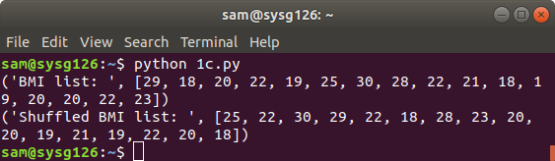

**1 D) Generating Random Integers using ‘random.randint()’** print("Random Integer: ", random.randint(1,5)) random_ints_list = []

fori in range(1,50):

n = random.randint(1,5) random_ints_list.append(n)

print("My random integer list: ", random_ints_list)

# OUTPUT:

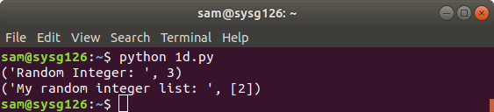

print("Random Float: ", random.random()) random_float_list = []

fori in range(1,5):

n = random.random() random_float_list.append(n)

print("My random float list: ", random_float_list)

# OUTPUT:

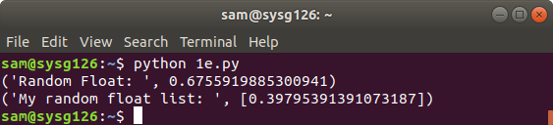

**Scale the random float numbers by multiplying our random number by 500**

random_float_list = [] fori in range(1,5):

n = random.random()*500 random_float_list.append(n)

print("My random float list: ", random_float_list)

# OUTPUT:

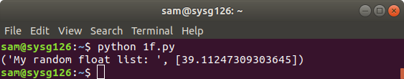

**generate random numbers between 100 and 500**

**r**andom_float_list = [] fori in range(1,10):

n = random.random()*500 if n>=100.0:

random_float_list.append(n)

print("My random float list: ", random_float_list)

# OUTPUT:

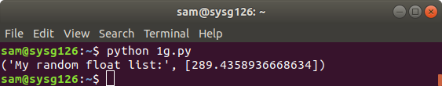

**1F) Computing Uniformly Distributed Numbers with ‘random.uniform()’**

import numpy as np

uniform_list = np.random.uniform(-10,1,50) print("Uniformly Distributed Numbers: ", uniform_list) **OUTPUT:**

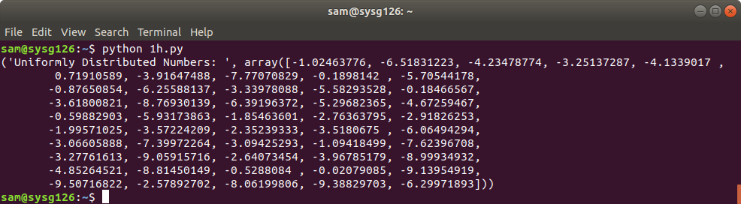

normal_list = np.random.uniform(-50,0,50) print("Normally Distributed Numbers: ", normal_list)

# OUTPUT:

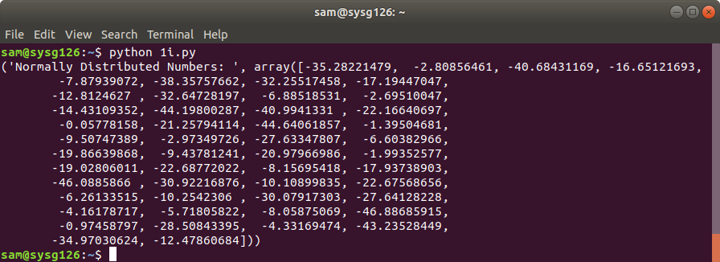

**EX.NO 02**

**PROGRAM**

1. **A) Create Sample:**

import numpy as np import pandas as pd np.random.seed(42) number_of_products=10

data={'product_id':np.arange(1,number_of_products+1).tolist(),'measure':np.round(np

.random.normal(loc=10,scale=0.5,size=number_of_products),3)} df=pd.DataFrame(data) real_mean=round(df['measure'].mean(),3)

df print(data) **OUTPUT:**

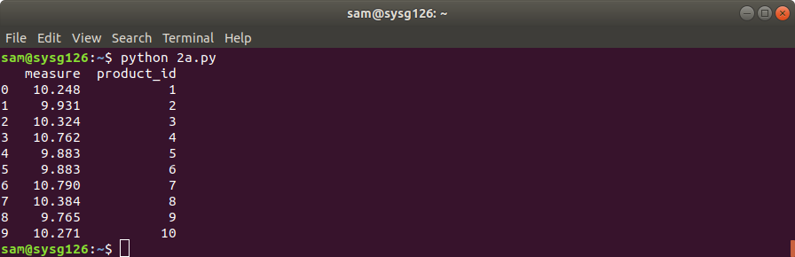

# 2 B) Implement Simple Random Sampling:

import numpy as np import pandas as pd np.random.seed(42) number_of_products=10

data={'product_id':np.arange(1,number_of_products+1).tolist(),'measure':np.round(np

.random.normal(loc=10,scale=0.5,size=number_of_products),3)} df=pd.DataFrame(data) simple_random_sample=df.sample(n=4).sort_values(by='product_id') simple_random_mean=round(simple_random_sample['measure'].mean(),3) simple_random_sample

print(simple_random_sample)

# OUTPUT:

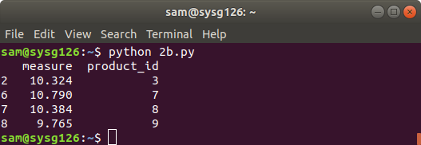

import numpy as np import pandas as pd number_of_students = 15

data = {'Id': np.arange(1, number_of_students+1).tolist(), 'height': [159, 171, 158, 162, 162, 177, 160, 175,

168, 171, 178, 178, 173, 177, 164]}

df = pd.DataFrame(data) print(df)

def systematic_sampling(df, step):

indexes = np.arange(0, len(df), step=step) systematic_sample = df.iloc[indexes] return systematic_sample

systematic_sample = systematic_sampling(df, 3) print(systematic_sample)

# OUTPUT:

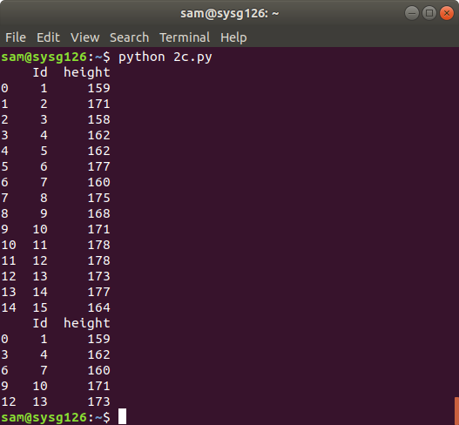

import numpy as np import pandas as pd

dic_data={"employee_id":np.arange(1,21),'value':np.random.randn(20)} df=pd.DataFrame(dic_data)

print(df) samples=df.sample(4).sort_values(by='employee_id') print(samples)

# OUTPUT:

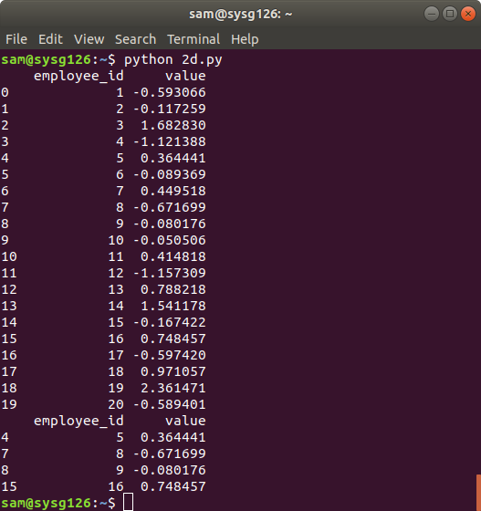

import pandas as pd import numpy as np number_of_products=6

data = {'product_id':np.arange(1, number_of_products+1).tolist(), 'product_strata':np.repeat([1,2], number_of_products/2).tolist(), 'measure':np.round(np.random.normal(loc=10, scale=0.5, size=number_of_products),3)}

df = pd.DataFrame(data) df

from sklearn.model_selection import StratifiedShuffleSplit from sklearn.model_selection import train_test_split

split = StratifiedShuffleSplit(n_splits=1, test_size=0.4) for x, y in split.split(df, df['product_strata']):

stratified_random_sample = df.iloc[y].sort_values(by='product_id') stratified_random_sample stratified_random_sample.groupby('product_strata').mean().drop(['product_id'],axis=1) print(stratified_random_sample)

# OUTPUT:

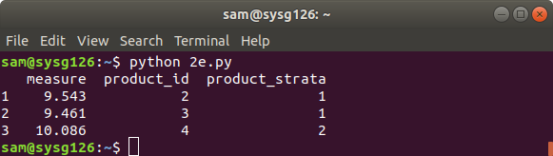

**PROGRAM:**

1. **A) One Sample Z-Test in Python:**

from statsmodels.stats.weightstats import ztest as ztest data = [88, 92, 94, 94, 96, 97, 97, 97, 99, 99,

105, 109, 109, 109, 110, 112, 112, 113, 114, 115]

ztest=ztest(data, value=100) print(ztest)

# OUTPUT:

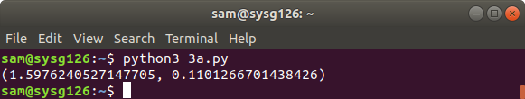

1. **B) Two Sample Z-Test in Python:**

from statsmodels.stats.weightstats import ztest as ztest cityA = [82, 84, 85, 89, 91, 91, 92, 94, 99, 99,

105, 109, 109, 109, 110, 112, 112, 113, 114, 114]

cityB = [90, 91, 91, 91, 95, 95, 99, 99, 108, 109,

109, 114, 115, 116, 117, 117, 128, 129, 130, 133]

ztest=ztest(cityA, cityB, value=0) print(ztest)

# OUTPUT:

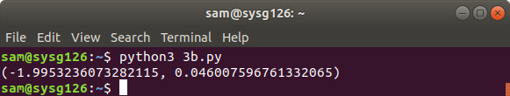

**PROGRAM:**

1. **A) verview Of Data Set:**

import pandas as pd import numpy as np import numpy.random import seaborn as sb

titanic_trian_data=sb.load_dataset('titanic') titanic_train_data.describe()

# OUTPUT:

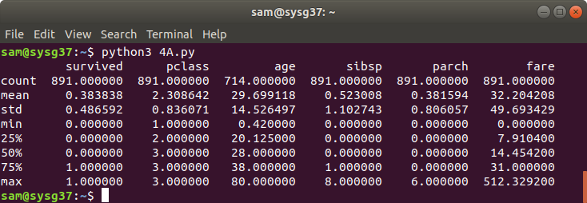

import pandas as pd import numpy as np import seaborn as sb

titanic_train_data=sb.load_dataset('titanic') temp=titanic_train_data[titanic_train_data['age'].notna()].age print(sb.histplot(temp))

# OUTPUT:

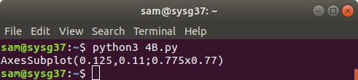

**4 C) Survived Data:**

survived_data = titanic_train_data(titanic_train_data['Survived']==1] survived_data[survived_data['Age'].notna ()].head()

# OUTPUT:

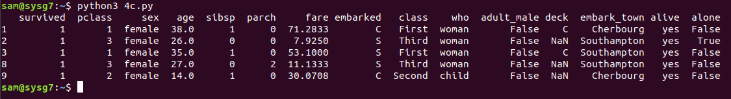

sample_list = []

for i in range (60):

sample_list_temp = np. random. Choice (survived_data[survived_data['Age'] .notna()].Age,60) .mean()

sample_list.append(sample_list_temp) sns.distplot (sample_list)

# OUTPUT:



**4 E) Z test**

from statsmodels.stats.weightstats import ztest from statsmodels.stats.weightstats import zconfint

HØ

else:

ztest Score, p_value= ztest (sample_list, value = mean_hØ, alternative='larger") print('p_value’,p_value)

print('ztest Score’,ztest Score)

if (p_value < 0.05): #The smaller the p-value, the stronger the evidence to reject the

print ()

print("Reject HØ with", (1-p_value) *100, '% level of confidence'); print ()

print("Fail to reject HØ"); print()

# OUTPUT:

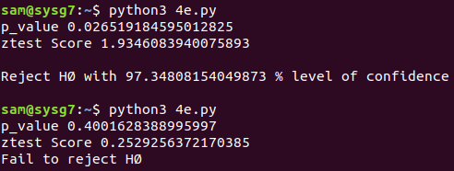

sns.distplot (survived_male_data[survived_male_data.Age.notna ()1.Age)

# OUTPUT:

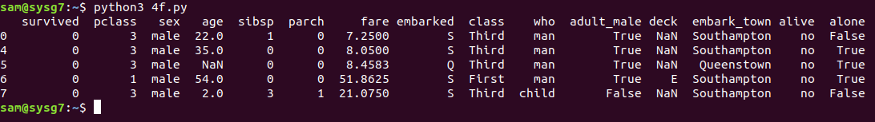

**4 G) Sample List male Using For Range (60)**

sample_list_male = []

for i in range (60):

sample_list_temp = np . random. Choice ( survived_male_data[survived_male_data.Age.notna()]. Age,60). Mean ()

sample_list_male.append(sample_list_temp) sns.distplot (sample_list_male)

# OUTPUT:

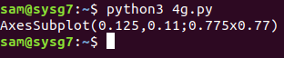

**4 H) survived_female_data**

sns.distplot (survived_female_data[survived_female_data.Age.notna()]. Age)

# OUTPUT:

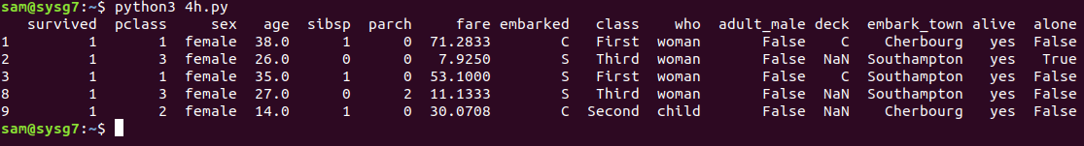

**4 I) Sample List Female Using For Range (60)**

sample_list_female = [ ]

for i in range(60):

sample_list_temp = np . random . choice ( survived_female_data[survived_female_date.Age . notna ()] . Age,60). Mean()

sample_list_female.append(sample_list_temp) sns.distplot (sample_list_female)

# OUTPUT:



**4 J) Z test**

from statsmodels.stats.weightstats import ztest from statsmodels.stats.weightstats import zconfint

Ztest_Score, p_value = ztest(x1=sample_list_male, x2 sample_list_female, value = 0, alternatives two-sided"]

print('p_value,p_value) print('ztest Score',ztest Score)

if (p_value < 0.05): #The smaller the p-value, the stronger the evidence to reject the HØ print()

print("Reject HØ with", (1-p_value)*100,' %level of confidence’); print()

else:

print("Fail to reject HØ "); print()

lower, upper = zconfint (x1=sample_list_male, value = 0,alpha=0.05, alternative = ‘two- sided")

print("with 95% considence interval we can say thta, Passenger Mean age is between, lower,"and", upper)

lower, upper = zconfint(x1=sample_list_female, value = 0,alpha 0.05, alternative="two- sided")

print("With 95% considence interval we can say thta, Passenger Mean age is between", lower, "and", upper)

# OUTPUT:

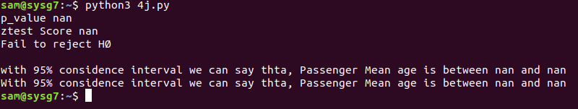

1. **K) z test**

from statsmodels.stats.weightstats import ztest from statsmodels.stats.weightstats import zconfint

ztest_score,p_value=ztest(x1=sample_list_male,x2=sample_list_female,value=0, alternative=’larger’)

print('p_value,p_value) print('ztest Score',ztest Score)

if (p_value < 0.05): #The smaller the p-value, the stronger the evidence to reject

the HO

else:

print()

print("Reject HØ with", (1-p_value)*100,’%level of confidence'); print()

print("Fail to reject HØ’’); print()

lower, upper = zconfint(x1=sample_list_male, value = 0,alpha=0.05,

alternative='two-sided')

print("With 95% considence interval we can say thta, Passenger Mean age is between", lower,"and", upper)

lower, upper = zconfint (x1=sample_list_female, value = 0,alpha=0.05, alternatives=’ two-sided’)

print("with 95% considence interval we can say thta, Passenger Hean age is between", lower, "and", upper)

# OUTPUT:

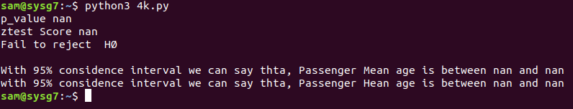

p = Ø.5Ø

ztestScore,p_value=proportions_ztest(count=153,nobs=survived_data.Age_range.count(),val ue=p, alternative ‘large’

print("Below is the calculation using Library") print('p_value,p_value)

print('ztest Score’,ztest Score)

if (p_value < 0.05): #The smaller the p-value, the stronger the evidence to reject the HØ print("Reject HØ with", (1-p_value)*100, '%level of confidence');

print() else:

print("Fail to reject HØ "); print()

z_score= ((153/290)-0.5)/(math.sqrt((0.5+0.5)/714)) print("z_score,z_score)

lower,upper=proportion_confint(count=153,nobs=survived_data.Age_range.count(), method="normal)

print (lower *100, "% to”, upper*100, “% of passengers who survived lie in the range of 20- 40 age ")

# OUTPUT:

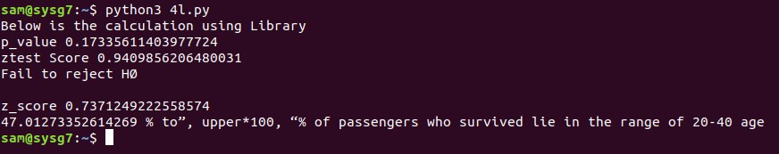

P = Ø.5 Ø

Ztest_ Score,p_value= proportions_ztest (count=385, nobs=titanic_train_data.

Age_range.count(),value=p,alternative=’large

print("Below is the calculation using Library") print('p_value.p_value)

print( ztest Scoreztest Score)

if (p_value < 0.05): #The smaller the p-value, the stronger the evidence to reject the H Ø print("Reject H Ø with’’. (1-p_value)*100,’% level of confidence");

print() else:

print("Fail to reject H Ø "); print()

z score = (0.539-0.5)/(math.sqrt((0.5*0.5)/714)) print("score ,z_score)

Lower, upper = proportion_confint (count=385, nobs =titanic_train_data.Age_range.count(), method="normal")

print (lower*100, “% to, upper*100,’’% of passengers lie in range of 20-40 age ")

# OUTPUT:

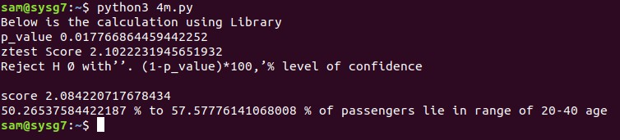

**PROGRAM:**

1. **A) ONE-SAMPLE T-TEST:**

import numpy as np from scipy import stats

population_ages1=stats.poisson.rvs(loc=18,mu=35,size=1500000) population_ages2=stats.poisson.rvs(loc=18,mu=10,size=1000000) population_ages=np.concatenate((population_ages1,population_ages2)) minnesota_ages1=stats.poisson.rvs(loc=18,mu=30,size=30) minnesota_ages2=stats.poisson.rvs(loc=18,mu=10,size=20) minnesota_ages=np.concatenate((minnesota_ages1,minnesota_ages2)) print(population_ages.mean())

print(minnesota_ages.mean())

# OUTPUT:

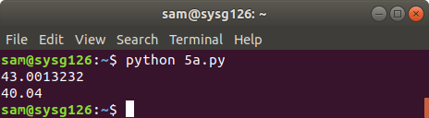

**5 B)**

import numpy as np from scipy import stats

population_ages1=stats.poisson.rvs(loc=18,mu=35,size=1500000) population_ages2=stats.poisson.rvs(loc=18,mu=10,size=1000000) population_ages=np.concatenate((population_ages1,population_ages2)) minnesota_ages1=stats.poisson.rvs(loc=18,mu=30,size=30) minnesota_ages2=stats.poisson.rvs(loc=18,mu=10,size=20) minnesota_ages=np.concatenate((minnesota_ages1,minnesota_ages2)) sa=stats.ttest_1samp(a=minnesota_ages,popmean=population_ages.mean()) print(sa)

# OUTPUT:

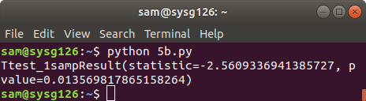

1. **C)**

import numpy as np from scipy import stats

population_ages1=stats.poisson.rvs(loc=18,mu=35,size=1500000) population_ages2=stats.poisson.rvs(loc=18,mu=10,size=1000000) population_ages=np.concatenate((population_ages1,population_ages2)) minnesota_ages1=stats.poisson.rvs(loc=18,mu=30,size=30) minnesota_ages2=stats.poisson.rvs(loc=18,mu=10,size=20) minnesota_ages=np.concatenate((minnesota_ages1,minnesota_ages2)) sa=stats.t.ppf(q=0.025, df=49)

print(sa)

# OUTPUT:

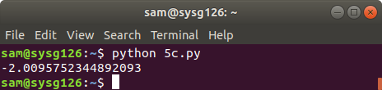

import numpy as np from scipy import stats

population_ages1=stats.poisson.rvs(loc=18,mu=35,size=1500000) population_ages2=stats.poisson.rvs(loc=18,mu=10,size=1000000) population_ages=np.concatenate((population_ages1,population_ages2)) minnesota_ages1=stats.poisson.rvs(loc=18,mu=30,size=30) minnesota_ages2=stats.poisson.rvs(loc=18,mu=10,size=20) minnesota_ages=np.concatenate((minnesota_ages1,minnesota_ages2)) sa=stats.t.ppf(q=0.975, df=49)

print(sa)

# OUTPUT:

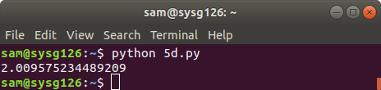

import numpy as np from scipy import stats

population_ages1=stats.poisson.rvs(loc=18,mu=35,size=1500000) population_ages2=stats.poisson.rvs(loc=18,mu=10,size=1000000) population_ages=np.concatenate((population_ages1,population_ages2)) minnesota_ages1=stats.poisson.rvs(loc=18,mu=30,size=30) minnesota_ages2=stats.poisson.rvs(loc=18,mu=10,size=20) minnesota_ages=np.concatenate((minnesota_ages1,minnesota_ages2)) sa=stats.t.cdf(x=-2.5742, df=49)*2

print(sa)

# OUTPUT:

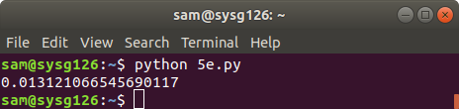

import numpy as np from scipy import stats

population_ages1=stats.poisson.rvs(loc=18,mu=35,size=1500000) population_ages2=stats.poisson.rvs(loc=18,mu=10,size=1000000) population_ages=np.concatenate((population_ages1,population_ages2)) minnesota_ages1=stats.poisson.rvs(loc=18,mu=30,size=30) minnesota_ages2=stats.poisson.rvs(loc=18,mu=10,size=20) minnesota_ages=np.concatenate((minnesota_ages1,minnesota_ages2)) sa=stats.t.interval(0.95, df=49, loc=minnesota_ages.mean(), scale=sigma) print(sa)

# OUTPUT:

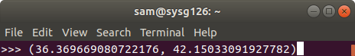

import numpy as np from scipy import stats

population_ages1=stats.poisson.rvs(loc=18,mu=35,size=1500000) population_ages2=stats.poisson.rvs(loc=18,mu=10,size=1000000) population_ages=np.concatenate((population_ages1,population_ages2)) minnesota_ages1=stats.poisson.rvs(loc=18,mu=30,size=30) minnesota_ages2=stats.poisson.rvs(loc=18,mu=10,size=20) minnesota_ages=np.concatenate((minnesota_ages1,minnesota_ages2)) sa=stats.t.interval(alpha=0.99, df=49, loc=minnesota_ages.mean(), scale=sigma) print(sa)

# OUTPUT:

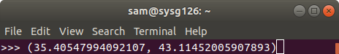

**EX.NO 06 PROGRAM**

1. **A) Two-Sample T-Test:**

import pandas as pd import numpy as np from scipy import stats

from scipy.stats import norm import matplotlib.pyplot as plt np.random.seed(12)

wisconsin_ages1 = stats.poisson.rvs(loc=18, mu=33, size=30) wisconsin_ages2 = stats.poisson.rvs(loc=18, mu=13, size=20) wisconsin_ages = np.concatenate((wisconsin_ages1, wisconsin_ages2)) print(wisconsin_ages.mean() )

stats.ttest_ind(a= minnesota_ages, b= wisconsin_ages,

equal_var=False) # Assume samples have equal variance?

Ttest_indResult(statistic=-1.7083870793286842, pvalue=0.09073104343957748)

# OUTPUT:

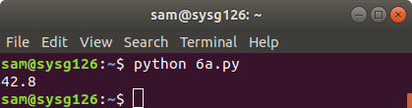

**6 B) Paired T-Test:**

np.random.seed(11)

before= stats.norm.rvs(scale=30, loc=250, size=100)

after = before + stats.norm.rvs(scale=5, loc=-1.25, size=100)

weight_df = pd.DataFrame({"weight_before":before, "weight_after":after, "weight_change":after-before})

weight_df.describe()

stats.ttest_rel(a = before, b = after) Ttest_relResult(statistic=2.5720175998568284, pvalue=0.011596444318439857)

# OUTPUT:

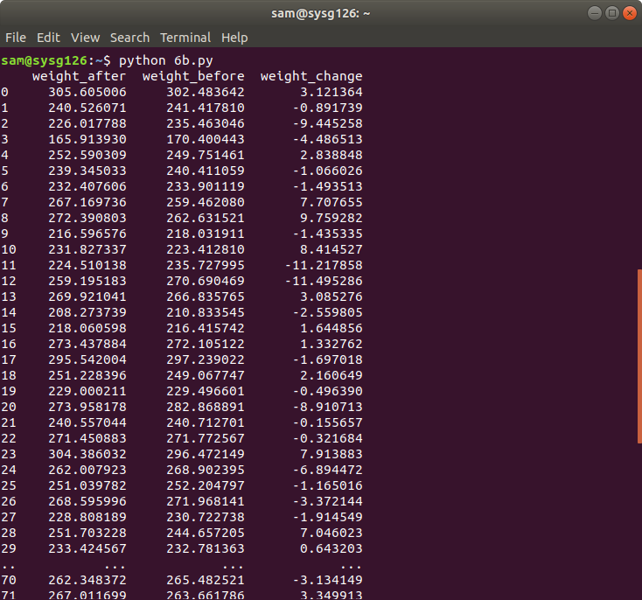

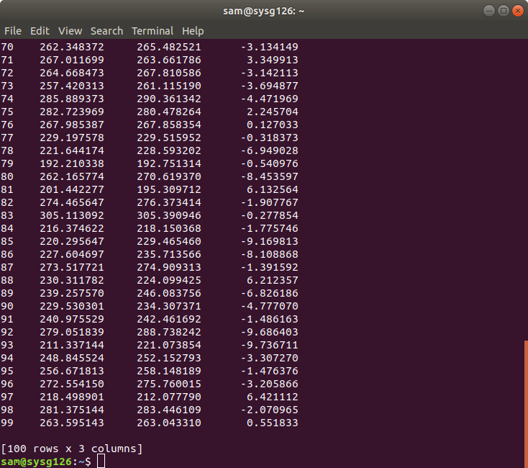

**6 C) Type I and Type II Error:**

import pandas as pd import numpy as np from scipy import stats

from scipy.stats import norm import matplotlib.pyplot as plt

plt.figure(figsize=(12,10))

plt.fill_between(x=np.arange(-4,-2,0.01),y1= stats.norm.pdf(np.arange(-4,-2,0.01))

,facecolor='red',alpha=0.35)

plt.fill_between(x=np.arange(-2,2,0.01),y1= stats.norm.pdf(np.arange(-2,2,0.01))

,facecolor='grey',alpha=0.35)

plt.fill_between(x=np.arange(2,4,0.01),y1= stats.norm.pdf(np.arange(2,4,0.01))

,facecolor='red',alpha=0.5)

plt.fill_between(x=np.arange(-4,-2,0.01),y1= stats.norm.pdf(np.arange(-4,-2,0.01),loc=3, scale=2) ,facecolor='grey',alpha=0.35)

plt.fill_between(x=np.arange(-2,2,0.01),y1= stats.norm.pdf(np.arange(-2,2,0.01),loc=3, scale=2) ,facecolor='blue',alpha=0.35)

plt.fill_between(x=np.arange(2,10,0.01),y1= stats.norm.pdf(np.arange(2,10,0.01),loc=3, scale=2),facecolor='grey',alpha=0.35)

plt.text(x=-0.8, y=0.15, s= "Null Hypothesis") plt.text(x=2.5, y=0.13, s= "Alternative") plt.text(x=2.1, y=0.01, s= "Type 1 Error") plt.text(x=-3.2, y=0.01, s= "Type 1 Error") plt.text(x=0, y=0.02, s= "Type 2 Error") plt.show()

# OUTPUT:

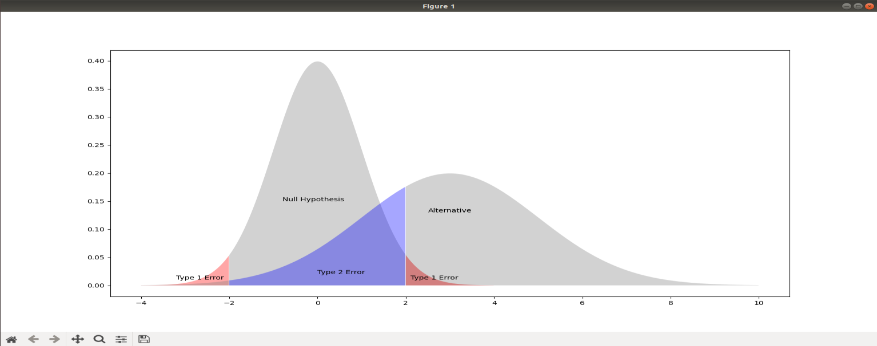

**PROGRAM:**

**i**mport pandas as pd import numpy as np import scipy.stats as stats a=[25,25,27,30,23,20]

b=[30,30,21,24,26,28]

c=[18,30,29,29,24,26]

list_of_tuples = list(zip(a, b,c))

df = pd.DataFrame(list_of_tuples, columns = ['A', 'B', 'C']) df

m1=np.mean(a) m2=np.mean(b) m3=np.mean(c)

print('Average mark for college A: {}'.format(m1)) print('Average mark for college B: {}'.format(m2)) print('Average mark for college C: {}'.format(m3)) m=(m1+m2+m3)/3

print('Overall mean: {}'.format(m)) SSb=6*((m1-m)**2+(m2-m)**2+(m3-m)**2)

print('Between-groups Sum of Squared Differences: {}'.format(SSb))

MSb=SSb/2

print('Between-groups Mean Square value: {}'.format(MSb)) err_a=list(a-m1)

err_b=list(b-m2) err_c=list(c-m3) err=err_a+err_b+err_c ssw=[]

for i in err: ssw.append(i**2)

SSw=np.sum(ssw)

print('Within-group Sum of Squared Differences: {}'.format(SSw))

MSw=SSw/15

print('Within-group Mean Square value: {}'.format(MSw))

F=MSb/MSw

print('F-score: {}'.format(F)) print(stats.f_oneway(a,b,c))

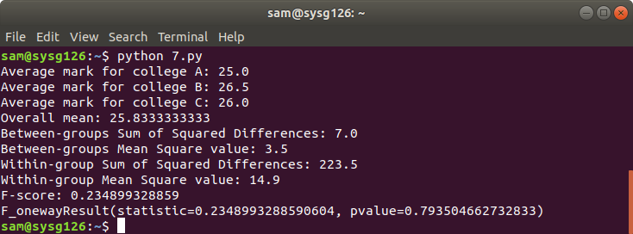

# PROGRAM:

import numpy as np

import matplotlib.pyplot as plt

def estimate_coef(x, y): n = np.size(x)

m_x, m_y = np.mean(x), np.mean(y) SS_xy = np.sum(y*x - n*m_y*m_x) SS_xx = np.sum(x*x - n*m_x*m_x) b_1 = SS_xy / SS_xx

b_0 = m_y - b_1*m_x return(b_0, b_1)

def plot_regression_line(x, y, b):

plt.scatter(x, y, color = "m",marker = "o", s = 30) y_pred = b[0] + b[1]*x

plt.plot(x, y_pred, color = "g") plt.xlabel('x')

plt.ylabel('y') plt.show()

x = np.array([25, 23, 25, 31, 32, 25, 36, 27, 28, 29])

y = np.array([3.2, 3, 3.5, 3, 3.6, 3.7, 3.3, 3.6, 3.2, 3.1])

b = estimate_coef(x, y)

print("Estimated coefficients:\nb_0 = {} nb_1 = {}".format(b[0], b[1])) plot_regression_line(x, y, b)

# OUTPUT:

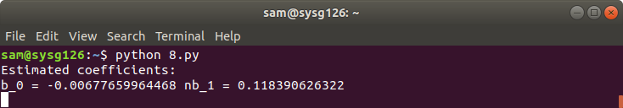

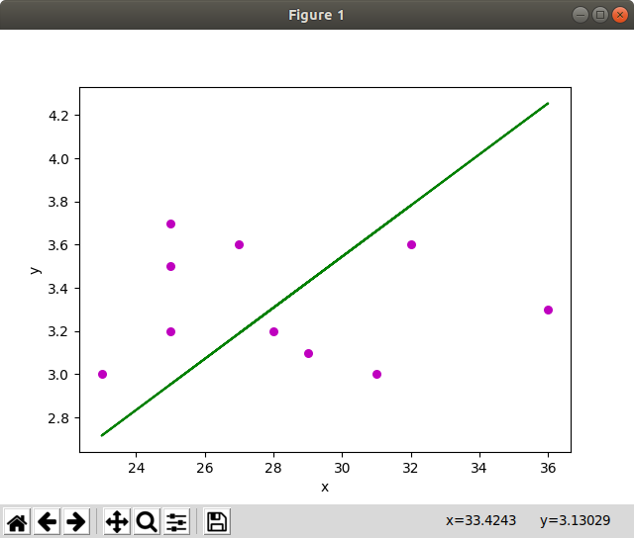

**PROGRAM**

import pandas as pd

from sklearn.model_selection import train_test_split from sklearn.linear_model import LogisticRegression from sklearn import metrics

import seaborn as sn

import matplotlib.pyplot as plt

candidates =

{'gmat':[780,750,690,710,680,730,690,720,740,690,610,690,710,680,770,610,580,650,540,5 90,620,600,550,550,570,670,660,580,650,660,640,620,660,660,680,650,670,580,590,690],

'gpa':[4,3.9,3.3,3.7,3.9,3.7,2.3,3.3,3.3,1.7,2.7,3.7,3.7,3.3,3.3,3,2.7,3.7,2.7,2.3,3.3,2,2.3,2.7,3,3

.3,3.7,2.3,3.7,3.3,3,2.7,4,3.3,3.3,2.3,2.7,3.3,1.7,3.7],

'work_experience':[3,4,3,5,4,6,1,4,5,1,3,5,6,4,3,1,4,6,2,3,2,1,4,1,2,6,4,2,6,5,1,2,4,6,5,1,2,1,4,5

], 'admitted':[1,1,0,1,0,1,0,1,1,0,0,1,1,0,1,0,0,1,0,0,1,0,0,0,0,1,1,0,1,1,0,0,1,1,1,0,0,0,0,1]}

df = pd.DataFrame(candidates,columns= ['gmat', 'gpa','work_experience','admitted']) print(df)

X = df[['gmat', 'gpa','work_experience']] y = df['admitted']

X_train,X_test,y_train,y_test = train_test_split(X,y,test_size=0.25,random_state=0) print (X_train)

print (y_train)

logistic_regression= LogisticRegression() logistic_regression.fit(X_train,y_train) y_pred=logistic_regression.predict(X_test)

confusion_matrix = pd.crosstab(y_test, y_pred, rownames=['Actual'], colnames=['Predicted']) sn.heatmap(confusion_matrix, annot=True)

print('Accuracy: ',metrics.accuracy_score(y_test, y_pred)) print (X_test)

print (y_pred)

print('confusion_matrix:', confusion_matrix, sep ='\n', end ='\n\n') plt.show()

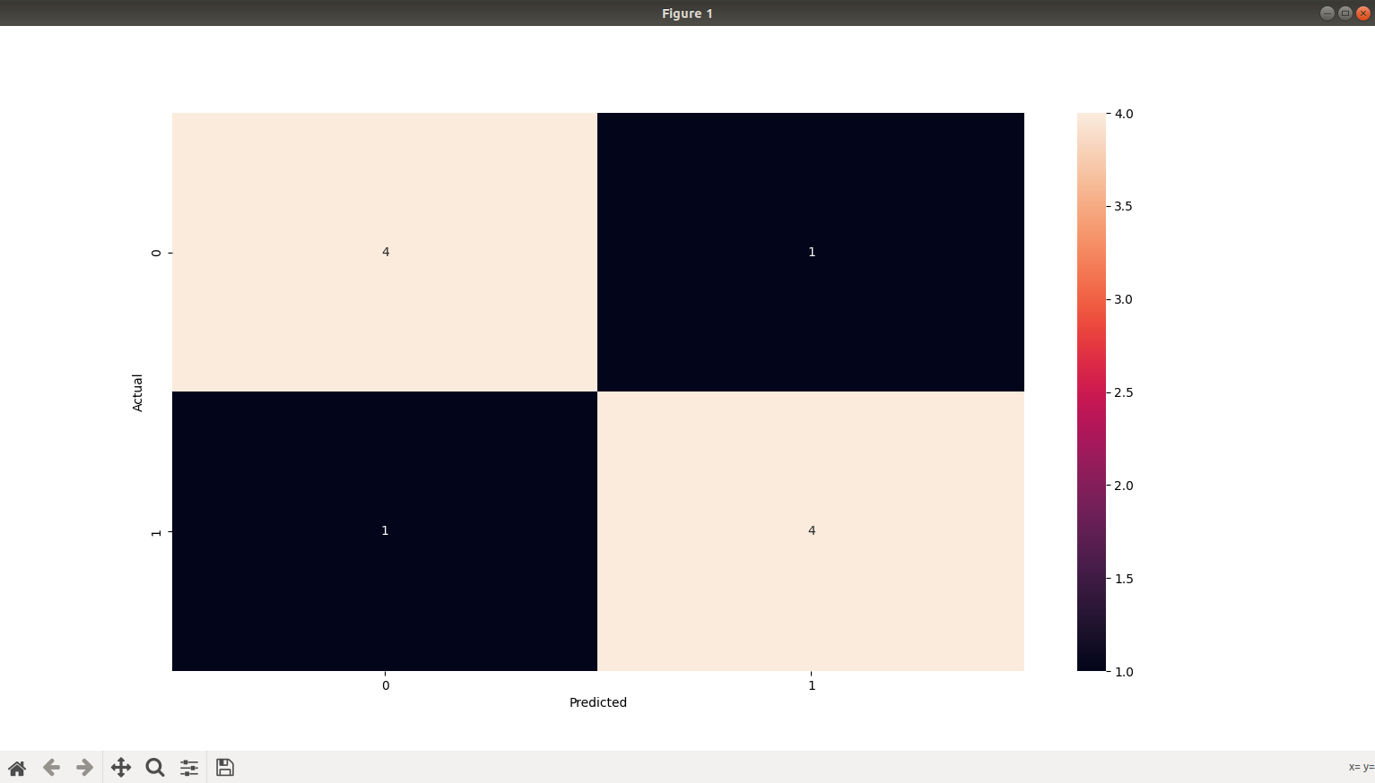

# PROGRAM:

import matplotlib.pyplot as plt import numpy as np

from sklearn import datasets, linear_model, metrics boston = datasets.load_boston(return_X_y=False)

X = boston.data y = boston.target

from sklearn.model_selection import train_test_split

X_train, X_test, y_train, y_test = train_test_split(X, y, test_size=0.4,random_state=1) reg = linear_model.LinearRegression()

reg.fit(X_train, y_train) print('Coefficients: ', reg.coef_)

print('Variance score: {}'.format(reg.score(X_test, y_test))) plt.style.use('fivethirtyeight')

plt.scatter(reg.predict(X_train), reg.predict(X_train) - y_train, color = "green", s = 10, label = 'Train data') plt.scatter(reg.predict(X_test), reg.predict(X_test) - y_test, color = "blue", s = 10, label = 'Test data')

plt.hlines(y = 0, xmin = 0, xmax = 50, linewidth = 2) plt.legend(loc = 'upper right')

plt.title("Residual errors") plt.show()

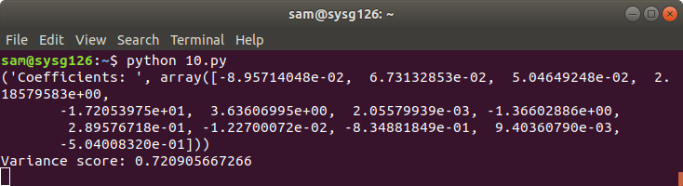

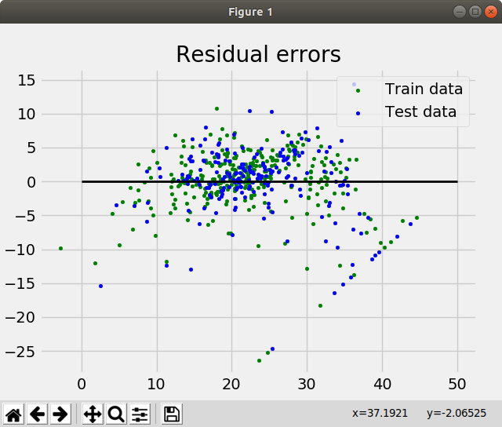

# PROGRAM 11 A)

from dateutil.parser import parse import matplotlib as mpl

import matplotlib.pyplot as plt import seaborn as sns

import numpy as np import pandas as pd

plt.rcParams.update({'figure.figsize': (10, 7), 'figure.dpi': 120})

df = pd.read_csv('https://raw.githubusercontent.com/selva86/datasets/master/a10.csv', parse_dates=['date'])

df.head() df =

pd.read_csv('https://raw.githubusercontent.com/selva86/datasets/master/MarketArrivals.csv') df = df.loc[df.market=='MUMBAI', :]

df.head().

import matplotlib.pyplot as plt

df = pd.read_csv('https://raw.githubusercontent.com/selva86/datasets/master/a10.csv', parse_dates=['date'], index_col='date')

def plot_df(df, x, y, title="", xlabel='Date', ylabel='Value', dpi=100): plt.figure(figsize=(16,5), dpi=dpi)

plt.plot(x, y, color='tab:red')

plt.gca().set(title=title, xlabel=xlabel, ylabel=ylabel) plt.show()

plot_df(df, x=df.index, y=df.value, title='Monthly anti-diabetic drug sales in Australia from 1992 to 2008.')

# OUTPUT

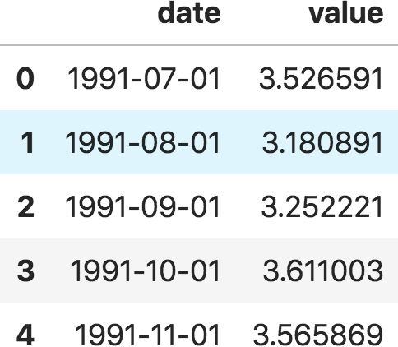

df = pd.read_csv('<https://raw.githubusercontent.com/selva86/datasets/master/MarketArrivals.csv>') df = df.loc[df.market=='MUMBAI', :]

df.head()

# OUTPUT:

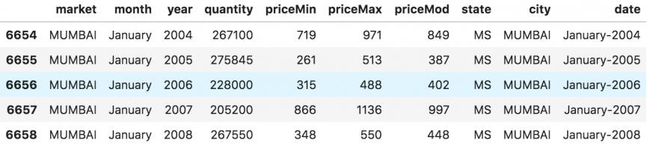

**11 C)**

import matplotlib.pyplot as plt

df = pd.read_csv('<https://raw.githubusercontent.com/selva86/datasets/master/a10.csv>', parse_dates=['date'], index_col='date')

def plot_df(df, x, y, title="", xlabel='Date', ylabel='Value', dpi=100): plt.figure(figsize=(16,5), dpi=dpi)

plt.plot(x, y, color='tab:red')

plt.gca().set(title=title, xlabel=xlabel, ylabel=ylabel) plt.show()

plot_df(df, x=df.index, y=df.value, title='Monthly anti-diabetic drug sales in Australia from 1992 to 2008.')

df = pd.read_csv('datasets/AirPassengers.csv', parse_dates=['date']) x = df['date'].values

y1 = df['value'].values

# OUTPUT:

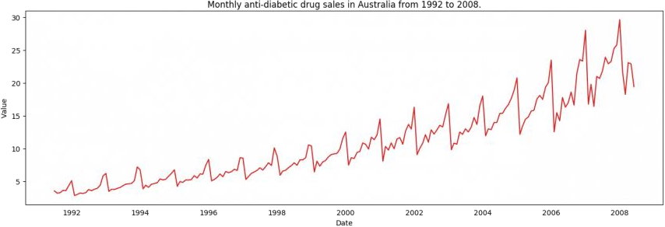

**11 D) PLOT**

fig, ax = plt.subplots(1, 1, figsize=(16,5), dpi= 120)

plt.fill_between(x, y1=y1, y2=-y1, alpha=0.5, linewidth=2, color='seagreen') plt.ylim(-800, 800)

plt.title('Air Passengers (Two Side View)', fontsize=16)

plt.hlines(y=0, xmin=np.min(df.date), xmax=np.max(df.date), linewidth=.5) plt.show()

# OUTPUT:

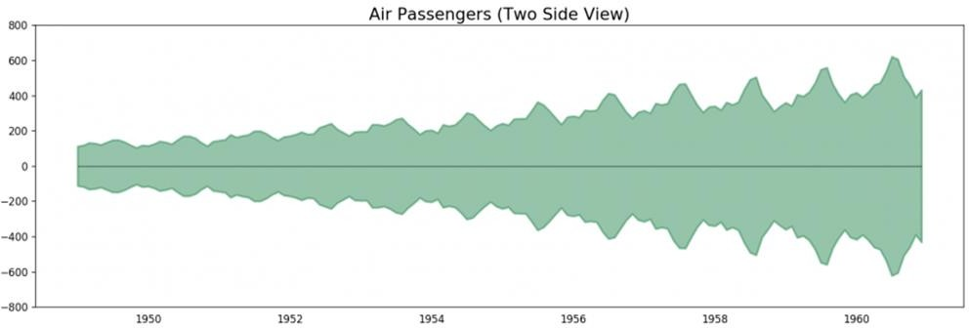

**11 E)**

df = pd.read_csv('<https://raw.githubusercontent.com/selva86/datasets/master/a10.csv>', parse_dates=['date'], index_col='date')

df.reset_index(inplace=True) df['year'] = [d.year for d in df.date]

df['month'] = [d.strftime('%b') for d in df.date] years = df['year'].unique() np.random.seed(100)

mycolors = np.random.choice(list(mpl.colors.XKCD_COLORS.keys()), len(years), replace=False)

plt.figure(figsize=(16,12), dpi= 80) for i, y in enumerate(years):

if i > 0:

plt.plot('month', 'value', data=df.loc[df.year==y, :], color=mycolors[i], label=y) plt.text(df.loc[df.year==y, :].shape[0]-.9, df.loc[df.year==y, 'value'][-1:].values[0], y,

fontsize=12, color=mycolors[i])

plt.gca().set(xlim=(-0.3, 11), ylim=(2, 30), ylabel='$Drug Sales$', xlabel='$Month$') plt.yticks(fontsize=12, alpha=.7)

plt.title("Seasonal Plot of Drug Sales Time Series", fontsize=20) plt.show()

# OUTPUT:

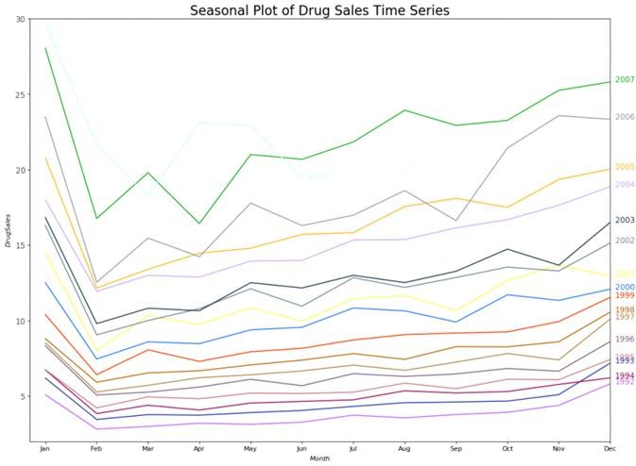

**11 F)**

df = pd.read_csv('<https://raw.githubusercontent.com/selva86/datasets/master/a10.csv>', parse_dates=['date'], index_col='date')

df.reset_index(inplace=True) df['year'] = [d.year for d in df.date]

df['month'] = [d.strftime('%b') for d in df.date] years = df['year'].unique()

fig, axes = plt.subplots(1, 2, figsize=(20,7), dpi= 80) sns.boxplot(x='year', y='value', data=df, ax=axes[0])

sns.boxplot(x='month', y='value', data=df.loc[~df.year.isin([1991, 2008]), :]) axes[0].set_title('Year-wise Box Plot\n(The Trend)', fontsize=18); axes[1].set_title('Month-wise Box Plot\n(The Seasonality)', fontsize=18) plt.show()

# OUTPUT:

